**Expo Instructions for dogemproto1**

**Step 1 – Download the repo from GitHub**

**Step 2 – Unzip the folder to your preferred directory and rename it if you would like to (I changed mine from dogemproto1-main to dogemproto1)**

**Step 3 – Open the command prompt you prefer to use. I use Node.js command prompt.**

**Step 4 – Navigate to where you saved your dogemproto1.**

cd <yourfoldername>

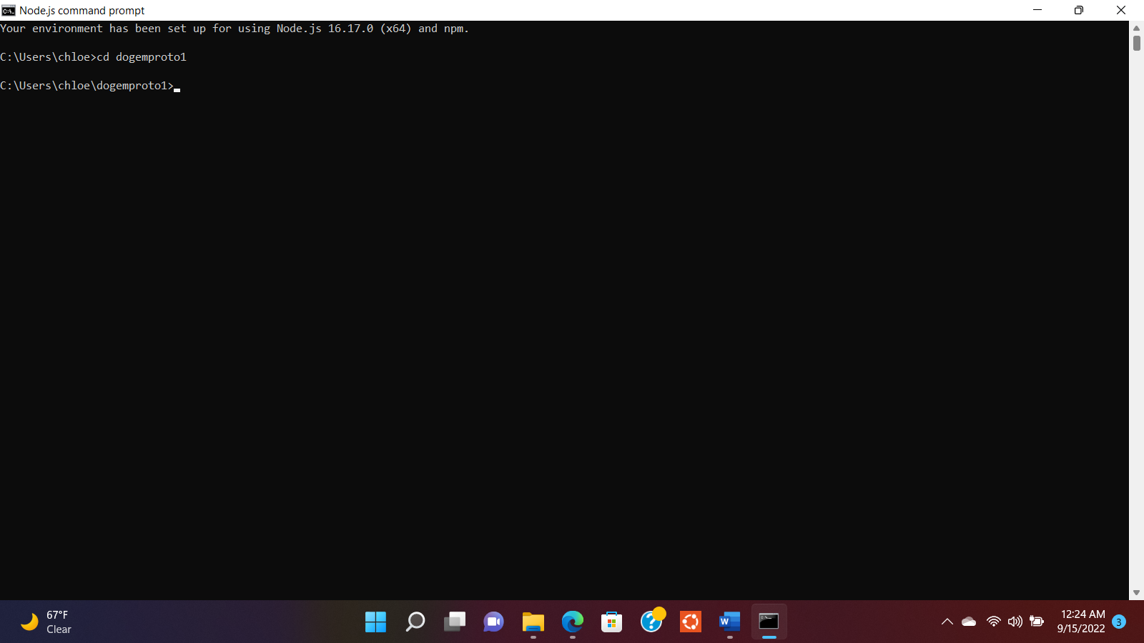

**Step 5 – Now that you’ve navigated to your directory, it is time to install**

**dependencies**

To use React Native’s navigation library, the following commands must be run:

To use the library:

npm install @react-navigation/native @react-navigation/native-stack

For expo’s peer dependencies:

expo install react-native-screens react-native-safe-area-context

After installation, you will also see your node_modules and .expo folders in the directory

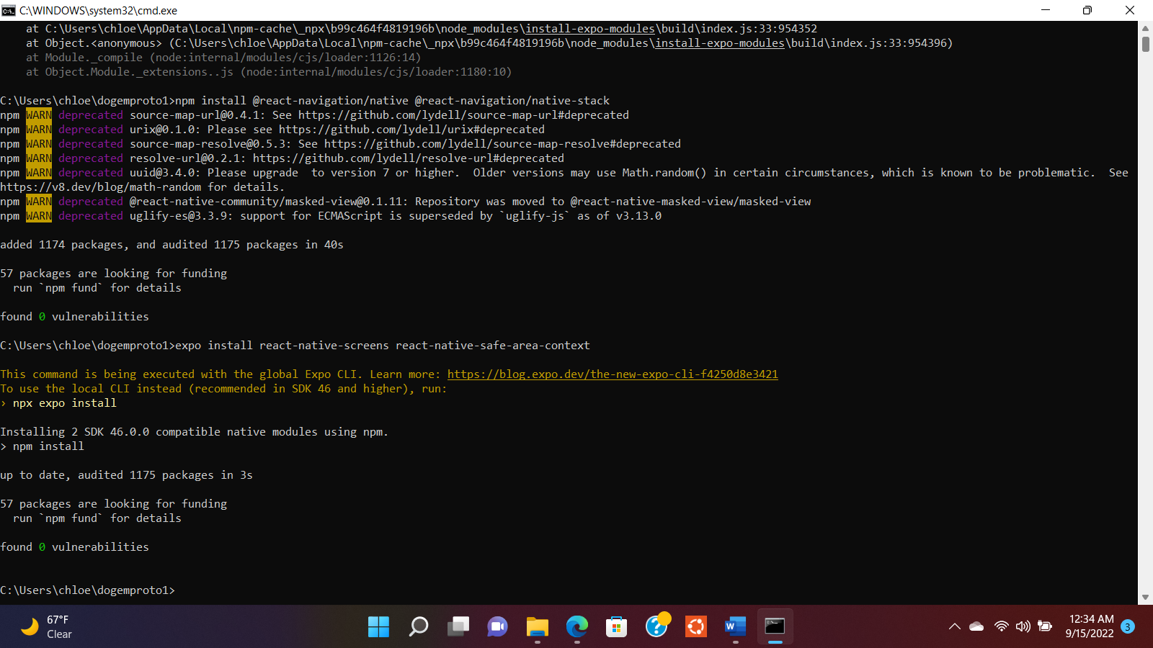

**Step 7 – Run the App**

**expo start > scan the QR code > navigate between pages on Expo Go**

expo start and QR code

Navigate between pages on Expo Go (If you want to run android, you can enter a)

You can also enter npx expo run:android into the terminal.

These are iPhone screenshots:

Onboarding

Login page

DogEm Page

*A full screen-by-screen walkthrough is provided in the repo as well, these are samples. **The tutorial is finished 😊!**